- FY 26 - Performance: Growth Areas
What are 3 wins you would like to celebrate since your last review? What led to those wins?

While these should ideally be tied to productivity and performance, if there is anything else that was transformational for you this month feel free to include it here!

In the comments section, make sure to save any references, shout outs and compliments given to you this month, both internally from colleagues and externally from candidates and clients.

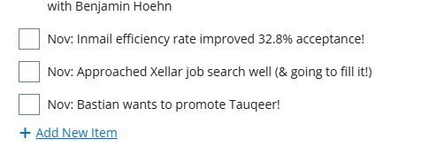

- FY 26 Action Items: Development Areas + Next Steps
Align with your TL on 3 areas of improvement to focus on before your next review. What next steps do you need to take to ensure you are accountable to them?

Be sure to review your 3 development areas from last month. In the comments section, include feedback/commentary on your progress against them.

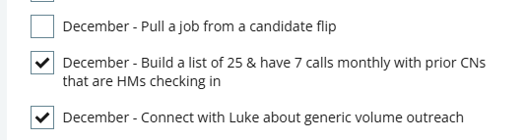

- Strategy + Vision: Progression Plan - My Career Vision & Personal Development
Vision (Planning for Success, Understanding our Founding Principles: Fairness & Meritocracy, Continuous Improvement, Conscious Capitalism) and Strategic Pillars (Specialization, Collaboration and Innovation)

Draft your personal mission/vision statement that details your career aspirations at GQR. This should be adjusted every 6-12 months as your role and responsibilities evolve, or upon promotion.

[*Protip: If you need additional inspiration, identify an individual(s) who you view as an aspirational role model. Interview them to discover what their role involves and how they got there. What things do you want to do more of? What things do you want to do less of? Describe key development areas that would help you ascend to the next level, that leverage your strengths, values, and passions].

Insert mission statement here: [To redefine what it means to be 'professional' in recruitment by showing that deep emotional investment isn't just acceptable – it's essential. I'm the recruiter who remembers to mail you a handwritten Christmas card, cries when you get the offer (or don't), and always picks up the phone, no matter what time it is. My team isn't just my priority; they're my family, and I'll move heaven and earth to see them succeed. Through masterful use of AI and an unwavering commitment to authentic connections, I create a recruitment experience that touches hearts while delivering extraordinary results.]

Below, outline 5 development areas and KDIs from your progression plan that are most key to work on. As you complete KDIs, add additional items from your progression plans.

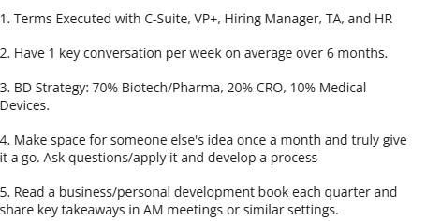

- Character + Behavior: Company Values (AAAs, IQ x EQ x MQ)
Character (Ambition, Adventure, Accountability) & Behavior (Personal Brand, Presentation, Action, Assets, Emotion – IQ, EQ, MQ)
Character: IQ, EQ, and MQ do not need to be evaluated, but are important qualities for success in this role.

- Intelligence Quotient refers to a person's intellect - including reasoning, problem-solving, and linguistic skills.
- Emotional Quotient refers to a person's ability to influence - crucial for interpersonal relationships and effective communication.
- Motivational Quotient refers to an individual's drive - persistence, ability to set and achieve goals, and pursue personal development.

Behavior: Self Score on your contribution to company values, providing your reasoning: Include evidence/reasoning each month in the comments.

- Ambition is measured by an unwavering determination to succeed, relentlessly pursuing your goals, setting high standards for yourself and continuously striving for excellence.
- Adventure requires stepping outside your comfort zone and trying new initiatives, and innovating how you/your team approaches work.
- Accountability requires being reliable, organized, taking ownership of tasks, maintaining transparency, and consistently delivering on commitments/meeting deadlines.
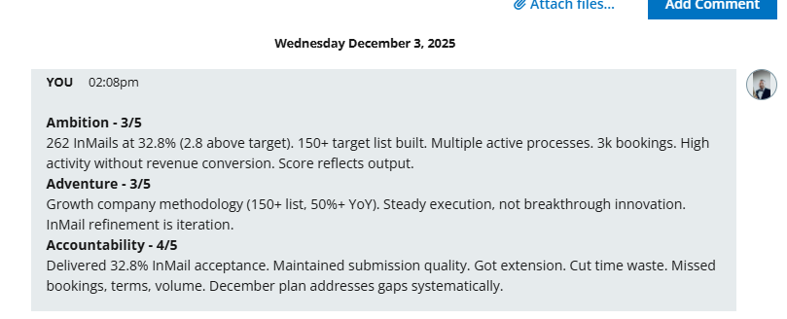
- FY 26 Output, Productivity + Pipeline: Progress vs Major Goals

Output (planning, marketing, mapping, call times, emails, headhunts, specs), Productivity (Key Conversations, Vacancies, CV submits, Interviews, Recruiter Clears), Pipeline (late stage processes, offers, bookings).

Include a screenshot each month of your BHA MPR dashboard as a record to reference in the files section of this objective.

Present and agree to 3 major quarterly goals with your manager that you believe are key components to success in your role. Please ensure you include HOW you'll approach achieving them. These can be tied to your quarterly bonus targets, or may be further personalized to you and your personal development.

